
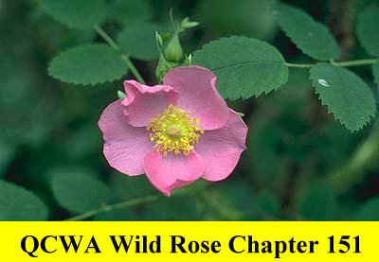
QUARTER CENTURY WIRELESS ASSOCIATION

WILD ROSE CHAPTER 151 – ALBERTA

Website: http://www.obsd.com/qcwa-chapter151

Application To Be A Friend

Date: RENEWAL NEW

Name: __________________________________________________ Call Sign: ___________________

Address: ________________________________________________ City: _______________________

Province: ________________________________________________ Postal Code: ________________

Telephone – Home: ___________________ Business: ____________________ Fax: _______________

E-mail address: _______________________________________________________________________

Year first licensed: __________ Spouse’s Name: __________________________ Call Sign: _______
(if applicable)
Birthday: ______________ Calls held (in order):_____________________________________

Brief outline of your radio activities: _____________________________________________________
__________________________________________________________________________________________________________________________________________________________________________
_____________________________________________________________________________________

Please note any activities or topics you could present or would like to see presented at your Chapter 151 meetings.
_____________________________________________________________________________________
_____________________________________________________________________________________

To save on printing and mailing costs would you be willing to receive via e-mail (if applicable) Chapter 151 information bulletins, notice of meetings, meeting minutes or other information Chapter 151 may wish to share with the members? YES: _________ NO: __________

Membership Dues: ________Year(s) x $5.00/Year = $ _________________

(maximum 3 years at a time)
Donations $ _________________

Grand Total Enclosed $ _________________

Please make dues payable to QCWA Wild Rose Chapter 151 and return completed form to:

Bill Maudsley, VE6GYM

Treasurer I certify that on the above date I have been a

QCWA Wild Rose Chapter 151 licensed radio amateur for less than 25 years.

8035 Elbow Drive SW
Calgary, AB T2V 1K5 Signature: _________________________________

