
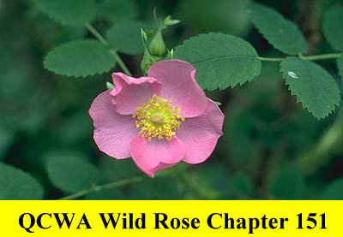
QUARTER CENTURY WIRELESS ASSOCIATION

WILD ROSE CHAPTER 151 – ALBERTA

Website: http://nicholasjanzen.ca/qcwa-chapter151/index.html

Application for Membership RENEWAL: NEW:

QCWA Member #: Expiry Date: Year 1st Joined:

Name: __________________________________________________ Call Sign: ___________________

Address: ________________________________________________ City: _______________________

Province: ________________________________________________ Postal Code: ________________

Telephone – Home: ___________________ Business: ____________________ Fax: _______________

E-mail address: _______________________________________________________________________

Year first licensed: __________ Spouse’s Name: __________________________ Call Sign: _______
(if applicable)
Birthday: Calls held (in order):______________________________________

Brief outline of your radio activities: _____________________________________________________
__________________________________________________________________________________________________________________________________________________________________________
_____________________________________________________________________________________

Please note any activities or topics you could present or would like to see presented at your Chapter 151 meetings.
_____________________________________________________________________________________
_____________________________________________________________________________________

To save on printing and mailing costs would you be willing to receive via e-mail (if applicable) Chapter 151 information bulletins, notice of meetings, meeting minutes or other information Chapter 151 may wish to share with the members? YES: _________ NO: __________

Membership Dues: ________Year(s) x $8.00/Year = $ _________________

(maximum 3 years at a time)
Donations $ _________________

Grand Total Enclosed $ _________________

Please make dues payable to QCWA Wild Rose Chapter 151 and return completed form to:

Bill Maudsley, VE6GYM

Treasurer

QCWA Wild Rose Chapter 151 Date:
8035 Elbow Drive SW
Calgary, AB T2V 1K5 Signature: _________________________________

